**Kanishka Ghosh**

**20BPS1125**

**Week 1 Assignment**

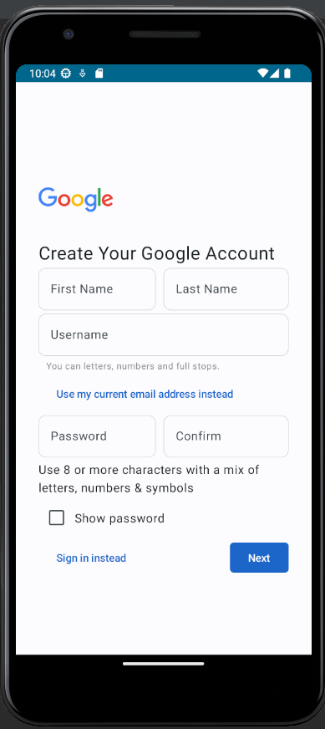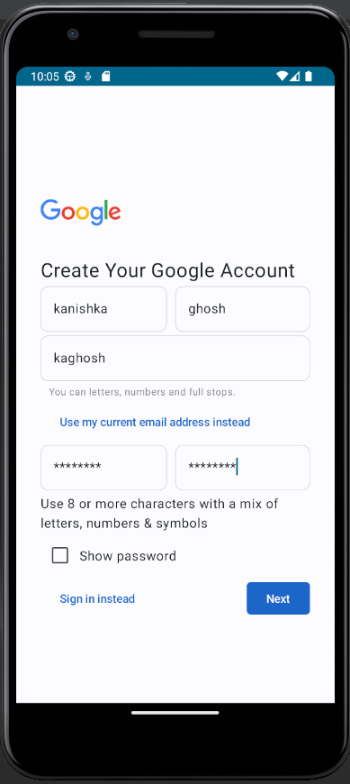

package com.example.googlecreateaccount_20BPS1125  
  
import android.os.Bundle  
import androidx.activity.ComponentActivity  
import androidx.activity.compose.setContent  
import androidx.compose.foundation.Image  
import androidx.compose.foundation.border  
import androidx.compose.foundation.layout.Arrangement  
import androidx.compose.foundation.layout.Column  
import androidx.compose.foundation.layout.Row  
import androidx.compose.foundation.layout.fillMaxHeight  
import androidx.compose.foundation.layout.fillMaxSize  
import androidx.compose.foundation.layout.fillMaxWidth  
import androidx.compose.foundation.layout.padding  
import androidx.compose.foundation.layout.size  
import androidx.compose.foundation.shape.RoundedCornerShape  
import androidx.compose.material3.Button  
import androidx.compose.material3.ButtonDefaults  
import androidx.compose.material3.Checkbox  
import androidx.compose.material3.ExperimentalMaterial3Api  
import androidx.compose.material3.Surface  
import androidx.compose.material3.Text  
import androidx.compose.material3.TextField  
import androidx.compose.material3.TextFieldDefaults  
import androidx.compose.runtime.Composable  
import androidx.compose.runtime.getValue  
import androidx.compose.runtime.mutableStateOf  
import androidx.compose.runtime.remember  
import androidx.compose.runtime.setValue  
import androidx.compose.ui.Alignment  
import androidx.compose.ui.Modifier  
import androidx.compose.ui.graphics.Color  
import androidx.compose.ui.res.painterResource  
import androidx.compose.ui.text.input.TextFieldValue  
import androidx.compose.ui.tooling.preview.Preview  
import androidx.compose.ui.unit.dp  
import androidx.compose.ui.unit.sp  
import com.example.googlecreateaccount.ui.theme.GoogleCreateAccountTheme  
  
class MainActivity : ComponentActivity() {  
 override fun onCreate(savedInstanceState: Bundle?) {  
 super.onCreate(savedInstanceState)  
 *setContent* **{** GoogleCreateAccountTheme **{** Surface(  
 modifier = Modifier.*fillMaxSize*()  
 ) **{** CreateAccount()  
 **}  
 }  
 }** }  
}  
  
@OptIn(ExperimentalMaterial3Api::class)  
@Composable  
fun CreateAccount() {  
 Column(  
 verticalArrangement = Arrangement.SpaceEvenly,  
 modifier = Modifier.*padding*(start = 30.*dp*, end = 30.*dp*, bottom = 100.*dp*, top = 100.*dp*)  
 .*fillMaxHeight*()  
 ) **{** Image(  
 painter = painterResource(id = R.drawable.*logo*),  
 contentDescription = "",  
 modifier = Modifier  
 .*size*(100.*dp*)  
 )  
 Text(text = "Create Your Google Account", fontSize = 24.*sp*)  
 Row(  
 horizontalArrangement = Arrangement.SpaceAround,  
 modifier = Modifier.*fillMaxWidth*()  
 ) **{** var fname by remember **{** *mutableStateOf*(TextFieldValue(""))  
 **}** var lname by remember **{** *mutableStateOf*(TextFieldValue(""))  
 **}** TextField(  
 value = fname,  
 onValueChange = **{** fname = **it }**,  
 placeholder = **{** Text("First Name") **}**,  
 colors = TextFieldDefaults.textFieldColors(  
 containerColor = Color.Transparent,  
 focusedIndicatorColor = Color.Transparent,  
 unfocusedIndicatorColor = Color.Transparent  
 ),  
 modifier = Modifier  
 .*fillMaxWidth*(0.5f)  
 .*padding*(end = 10.*dp*).*border*(  
 0.5.*dp*, color = Color.LightGray,  
 *RoundedCornerShape*(10.*dp*)  
 )  
 )  
 TextField(  
 value = lname,  
 onValueChange = **{** lname = **it }**,  
 placeholder = **{** Text("Last Name") **}**,  
 colors = TextFieldDefaults.textFieldColors(  
 containerColor = Color.Transparent,  
 focusedIndicatorColor = Color.Transparent,  
 unfocusedIndicatorColor = Color.Transparent  
 ),  
 modifier = Modifier  
 .*border*(  
 0.5.*dp*, color = Color.LightGray,  
 *RoundedCornerShape*(10.*dp*)  
 )  
 )  
 **}** Row **{** var uname by remember **{** *mutableStateOf*(TextFieldValue(""))  
 **}** TextField(  
 value = uname,  
 onValueChange = **{** uname = **it }**,  
 placeholder = **{** Text("Username") **}**,  
 colors = TextFieldDefaults.textFieldColors(  
 containerColor = Color.Transparent,  
 focusedIndicatorColor = Color.Transparent,  
 unfocusedIndicatorColor = Color.Transparent  
 ),  
 modifier = Modifier  
 .*fillMaxWidth*()  
 .*border*(  
 0.5.*dp*, color = Color.LightGray,  
 *RoundedCornerShape*(10.*dp*)  
 )  
 )  
 **}** Text(text = "You can letters, numbers and full stops.", fontSize = 12.*sp*, color = Color.Gray, modifier = Modifier.*padding*(start = 10.*dp*))  
 Button(onClick = **{** /\**TODO*\*/ **}**,  
 colors = ButtonDefaults.outlinedButtonColors(contentColor = Color.Transparent),  
 ) **{** Text(text = "Use my current email address instead", color = *Color*(27, 102, 201))  
 **}** Row(  
 verticalAlignment = Alignment.CenterVertically,  
 horizontalArrangement = Arrangement.SpaceAround,  
 modifier = Modifier.*fillMaxWidth*()  
 ) **{** var pass by remember **{** *mutableStateOf*(TextFieldValue(""))  
 **}** var pass2 by remember **{** *mutableStateOf*(TextFieldValue(""))  
 **}** TextField(  
 value = pass,  
 onValueChange = **{** pass = **it }**,  
 placeholder = **{** Text("Password") **}**,  
 modifier = Modifier  
 .*fillMaxWidth*(0.5f)  
 .*padding*(end = 10.*dp*)  
 .*border*(  
 0.5.*dp*, color = Color.LightGray,  
 *RoundedCornerShape*(10.*dp*)  
 ),  
 colors = TextFieldDefaults.textFieldColors(  
 containerColor = Color.Transparent,  
 focusedIndicatorColor = Color.Transparent,  
 unfocusedIndicatorColor = Color.Transparent  
 ),  
 )  
 TextField(  
 value = pass2,  
 onValueChange = **{** pass2 = **it }**,  
 placeholder = **{** Text("Confirm") **}**,  
 colors = TextFieldDefaults.textFieldColors(  
 containerColor = Color.Transparent,  
 focusedIndicatorColor = Color.Transparent,  
 unfocusedIndicatorColor = Color.Transparent  
 ),  
 modifier = Modifier  
 .*border*(  
 0.5.*dp*, color = Color.LightGray,  
 *RoundedCornerShape*(10.*dp*)  
 )  
 )  
 **}** Text(text = "Use 8 or more characters with a mix of letters, numbers & symbols")  
 Row(  
 verticalAlignment = Alignment.CenterVertically  
 ) **{** var isChecked by remember **{** *mutableStateOf*(false)  
 **}** Checkbox(checked = isChecked, onCheckedChange = **{** isChecked = **it }**)  
 Text(text = "Show password")  
 **}** Row(  
 verticalAlignment = Alignment.CenterVertically,  
 horizontalArrangement = Arrangement.SpaceBetween,  
 modifier = Modifier.*fillMaxWidth*()  
 ) **{** Button(onClick = **{** /\**TODO*\*/ **}**,  
 colors = ButtonDefaults.buttonColors(containerColor =Color.Transparent,contentColor= *Color*(27, 102, 201))) **{** Text(text = "Sign in instead")  
 **}** Button(onClick = **{** /\**TODO*\*/ **}**,  
 shape = *RoundedCornerShape*(5.*dp*),  
 colors = ButtonDefaults.buttonColors(containerColor = *Color*(27, 102, 201), contentColor = Color.White)) **{** Text(text = "Next")  
 **}  
 }  
 }**}  
  
@Preview(showBackground = true)  
@Composable  
fun CreateAccountPreview() {  
 GoogleCreateAccountTheme **{** CreateAccount()  
 **}**}